1. Do the below programs in anonymous function & IIFE

* 1. Print odd numbers in an array
  2. Convert all the strings to title caps in a string array
  3. Sum of all numbers in an array
  4. Return all the prime numbers in an array
  5. Return all the palindromes in an array
  6. Return median of two sorted arrays of the same size
  7. Remove duplicates from an array
  8. Rotate an array by k times

// Question 1

//a.) Print odd numbers in an array

let arr = [1, 2, 3, 4, 1001, 507, 199, 8, 9, 10, 11];

let result = [];

const oddNumber = function (a) {

a.forEach(v => {

if (v % 2) result.push(v);

})

return result;

}

console.log(`a. ${oddNumber(arr)}`);

// b.) Convert all the strings to title caps in a string array

const str = ['mango', 'apple', 'banana', 'melon', 'orange'];

const titleCap = function (s) {

s.forEach((v, i) => {

str[i] = v.charAt(0).toUpperCase() + v.substr(1).toLowerCase();

})

return str;

}

console.log(`b. ${titleCap(str)}`)

// c.) Sum of all numbers in an array

let res;

const sum = function (a) {

res = a.reduce((x, y) => x + y);

return res;

}

console.log(`c. ${sum(arr)}`)

// d.) Return all the prime numbers in an array;

let r = [];

let c = 0;

const prime = function (a) {

a.forEach(v => {

if (v === 2 || v === 3) r.push(v);

for (let j = 2; j \* j <= v; j++) {

if (v % j !== 0) ++c;

}

if (c > 1) r.push(v);

c = 0;

})

return r;

}

console.log(`d. ${prime(arr)}`)

// e.) Return all the palindromes in an array

const arr1 = ['malayalam', 'tamil', 'madam', 'refer', 'thilip'];

let e = [];

const palindrome = function (a) {

a.forEach(v => {

let reverse = v.split("").reverse().join("");

if (v === reverse) e.push(v);

})

return e;

}

console.log(`e. ${palindrome(arr1)}`)

// f.) Return median of two sorted arrays of same size

let a1 = [1, 5, 3];

let a2 = [4, 6, 2, 7];

let ans;

const median = function (a, b) {

let c = [...a, ...b];

c.sort((a, b) => a - b)

let d = Math.trunc(c.length / 2);

(!(c.length % 2)) ? ans = ((c[d - 1] + c[d]) / 2) : ans = c[d];

return ans

}

console.log(`e. ${median(a1, a2)}`);

// h.) Rotate an array by k times

let arr2 = [1, 2, 3, 4, 5, 6, 7, 8, 9, 10]

let k = 5;

for (let i = 1; i <= k; i++) {

let b = arr2[0];

for (let j = 0; j < arr2.length; j++) {

arr2[j] = arr2[j + 1];

if (j === arr2.length - 1) arr2[j] = b;

}

}

console.log(`h. ${arr2}`);

Console:

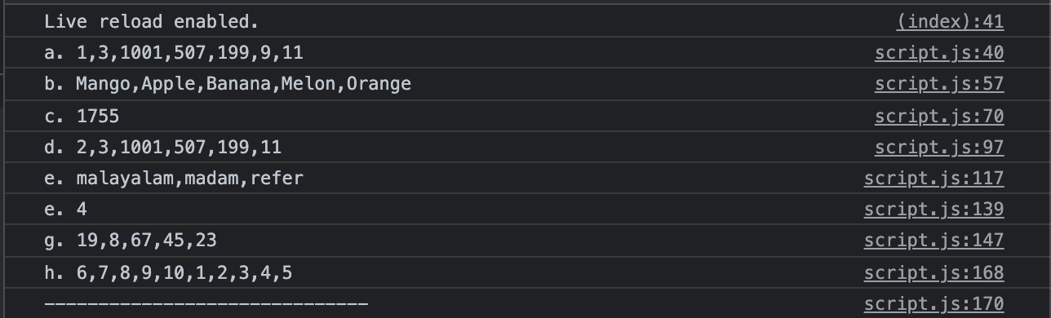

2. Do the below programs in arrow functions

* 1. Print odd numbers in an array
  2. Convert all the strings to title caps in a string array
  3. Sum of all numbers in an array
  4. Return all the prime numbers in an array
  5. Return all the palindromes in an array

// Arrow function

// a.) Print odd numbers in an array

let arrA = [1, 2, 3, 4, 1001, 507, 199, 8, 9, 10, 11];

let resultA = [];

const arrowOdd = (a) => {

a.forEach(v => {

if (v % 2) resultA.push(v);

})

return resultA;

}

console.log(`a. ${arrowOdd(arrA)}`);

// b.) Convert all the strings to title caps in a string array

const strA = ['mango', 'apple', 'banana', 'melon', 'orange'];

const titleCapArr = (s) => {

s.forEach((v, i) => {

strA[i] = v.charAt(0).toUpperCase() + v.substr(1).toLowerCase();

})

return strA;

}

console.log(`b. ${titleCapArr(str)}`);

// c.) Sum of all numbers in an array

let resA;

const sumArr = (a) => { resA = a.reduce((x, y) => x + y) }

console.log(`c. ${sumArr(arrA)}`);

// d.) Return all the prime numbers in an array

let rA = [];

let cA = 0;

const primeArr = (a) => {

a.forEach(v => {

if (v === 2 || v === 3) rA.push(v);

for (let j = 2; j \* j <= v; j++) {

if (v % j !== 0) ++cA;

}

if (cA > 1) rA.push(v);

cA = 0;

})

return rA;

}

console.log(`d. ${primeArr(arrA)}`);

// e.) Return all the palindromes in an array

const arr1A = ['malayalam', 'tamil', 'madam', 'refer', 'thilip'];

let eA = [];

const palindromeArr = (a) => {

a.forEach(v => {

let reverse = v.split("").reverse().join("");

if (v === reverse) eA.push(v);

})

return eA;

}

console.log(`e. ${palindromeArr(arr1A)}`)

Console:

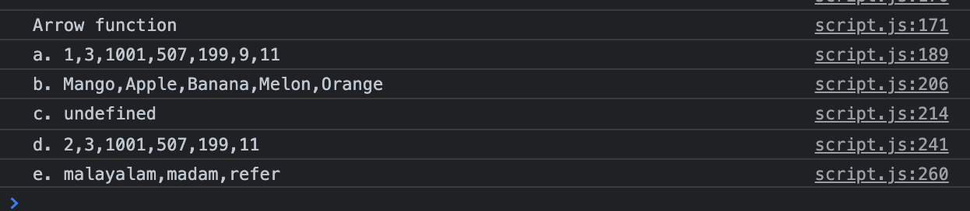

Thank you!!!

Have a good day!!!